# Warmup: Understanding if-else in Python

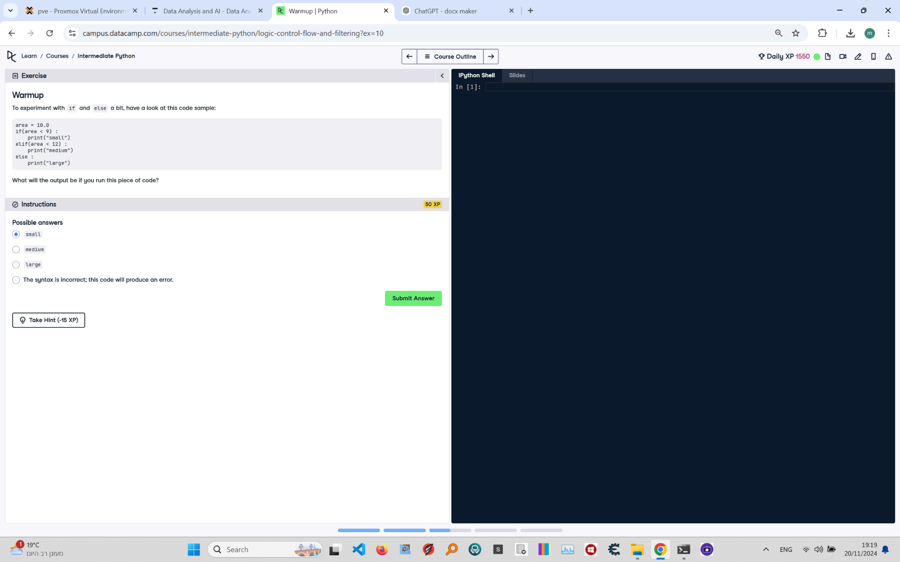

**Question:**

To experiment with `if` and `else` a bit, have a look at this code sample:  
```python  
area = 10.0  
if area < 9:  
 print("small")  
elif area < 12:  
 print("medium")  
else:  
 print("large")  
```  
What will the output be if you run this piece of code?

**Possible answers:**

1. small  
2. medium  
3. large  
4. The syntax is incorrect; this code will produce an error.

**Answer:**

The answer is **medium**.

**Explanation:**

1. **Variable initialization**: The variable `area` is set to 10.0.  
2. **First condition**: The `if` statement checks if `area < 9`. Since 10.0 is not less than 9, this block is skipped.  
3. **Second condition**: The `elif` statement checks if `area < 12`. Since 10.0 is less than 12, this block is executed, and `"medium"` is printed.  
4. **Else block**: The `else` block is not executed because the `elif` condition was satisfied.